OHS RISK MANAGEMENT PLAN
Réf. Doc : | PGR-01-2025
Version : | 1.0
Date :
Prepared by: | QHSE Manager

1. Scope, Context, and Criteria
The objective of this stage is to customize the risk management process and establish the parameters for Occupational Health and Safety (OHS) risk management.
At this level, Telcotec defines the scope of risk management application—whether it pertains to strategic, operational, program, project, or other activities—while considering the company’s objectives, expected outcomes, tools, techniques, resources, responsibilities, record-keeping, and more. The context should reflect the specific environment of the activity to which the risk management process is applied.
Similarly, our company, Telcotec, will determine the amount and type of risk that can or cannot be accepted in relation to its objectives.
To support decision-making, criteria should be established to assess the significance of risks. These criteria are dynamic and should be reviewed periodically and adjusted as needed.

2. Communication

The objective of communication is to help the entire team understand the risks, the basis on which decisions are made, and the reasons why specific measures are necessary. Communication aims to promote awareness and understanding of risks, while consultation involves gathering feedback and information to support decision-making.

Communication should take place at every stage and throughout the entire risk management process. This ensures the integration of various areas of expertise and guarantees that different perspectives are properly considered in defining criteria and assessing risks.

3. Identification of Hazards and Risks
Understanding the difference between a hazard and a risk is a key element of a successful risk assessment. According to ISO 45001:

- Hazard: A source that could potentially cause injuries or illnesses.
  - Hazards may include sources capable of causing harm, dangerous situations, or circumstances that could lead to injuries and illnesses.

- Risk: The effect of uncertainty.
  - An effect is a deviation from the expected—whether positive or negative.
  - Uncertainty refers to the state, even partial, of a lack of information, understanding, or knowledge related to an event, its consequence, or its probability.

The identification of hazards and risks helps the organization recognize and understand workplace hazards affecting workers to evaluate, prioritize, and either eliminate hazards or reduce occupational health and safety (OHS) risks.

The hazard identification process must be continuous and proactive.

To compile a list of risk sources and their consequences, the team should consider the following questions:
- What could go wrong? (Risk)
- How serious could it be? (Consequences/Impact)
- How often could it happen? (Probability)

Strategies to Address These Questions:
- Brainstorming
- Scenario development (e.g., "What if" situations)
- Reviewing past incidents, injury rates, and fatalities to identify processes or activities requiring further examination or more attention in hazard and risk assessment.

4. Risk Analysis
Risk analysis involves a detailed examination of uncertainties, risk sources, consequences, probabilities, events, scenarios, controls, and their effectiveness.
- Probability: The likelihood of an event occurring.
- Consequence/Impact: The outcome of an event that affects objectives.
  - A consequence can be certain or uncertain and may have direct or indirect positive or negative effects on objectives.
  - Consequences can be expressed qualitatively or quantitatively.
A Risk Matrix or Risk Diagram is a simple and visual tool commonly used to assess the level of risk and support the decision-making process.
Our company, TELCOTEC, will define its own criteria for consequence and probability based on its context and current objectives (Step 1).
Probability and impact can be expressed either qualitatively or quantitatively.

Probability | Qualitative Description | Quantitative Description
Rare | Conceivable but extremely unlikely | Less than one event in 100 years
Unlikely | Possible but not very likely | One event between 10–100 years
Possible | Likely, but not certain | One event between 1–10 years
Very Likely | Will probably occur | More than one event per year
Almost Certain | Extremely likely | More than one event per month

Impact | Qualitative Description | Quantitative Description
Negligible | Near miss, no injury or illness | 1
Minor | First-aid injury | 2
Moderate | Moderate injury/illness, reversible compromise, biological exposure | 3
Severe | Serious injury/illness, temporary disability, hazardous incident | 4
Critical | Multiple fatalities and/or significant irreversible effects | 5

At this stage, we can build a risk matrix to calculate the magnitude of potential consequences (impact levels) and the likelihood (probability levels) of these consequences occurring.
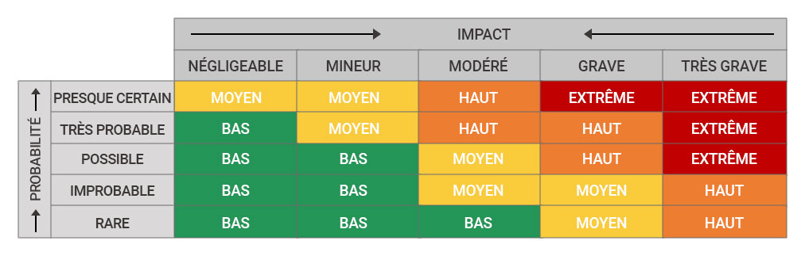

5. Risk Assessment
The objective of risk assessment is to compare the results of risk analysis with established criteria to determine where additional measures are necessary.
Risk evaluation criteria are also defined in Step 1.
Risk Level | Risk Acceptability | Immediate Action Required
Low | Acceptable | Continue the process but monitor regularly.
Medium | Fairly acceptable | Keep the process moving; however, a control plan should be developed and implemented as soon as possible.
High | Unacceptable | Investigate the process and implement controls immediately.
Extrême Extreme | Unacceptable | Stop the process and implement controls.
The results of the risk assessment must be recorded, reported, and validated at the appropriate levels of TELCOTEC.

6. Risk Treatment

The objective of risk treatment is to select and implement options to address risks.
Risk treatment involves an iterative process of:
- Formulating and selecting risk treatment options;
- Planning and implementing risk treatment;
- Evaluating the effectiveness of this treatment;
- Deciding whether the remaining risk is acceptable;
- If it is not acceptable, applying another treatment.

7. Monitoring and Review

Risk management is an ongoing process that must be monitored and reviewed to ensure its continued relevance and effectiveness.
We will review the risk management process at planned intervals or when:
- They are no longer effective;
- Workplace changes occur that may introduce new risks;
- An accident or near-miss has occurred;
- Changes in legal requirements take place;
- Audit results reveal non-conformities or opportunities for improvement;
- Workers raise issues or suggest improvements.

Occupational health and safety (OHS) risks can be monitored through:
- Audits;
- Inspections;
- Exposure monitoring;
- Reviewing performance indicators.

Monitoring and reviewing OHS risk management performance ensures continuous improvement.

8. Records and Reports

The objective of reporting is to:
- Communicate risk management activities and results across the organization;
- Provide information for decision-making;
- Improve risk management activities;
- Facilitate interaction with stakeholders, including those responsible for risk management activities.

Conclusion

The occupational health and safety risk management process enables us to act proactively rather than reactively, minimizing risks before they cause injuries or illnesses to workers.

